**Ideation Phase**

**Define the Problem Statements**

|  |  |
| --- | --- |
| Date | 28 October 2022 |
| Team ID | PNT2022TMID43155 |
| Project Name | Plasma Donor Application |
| Maximum Marks | 2 Marks |

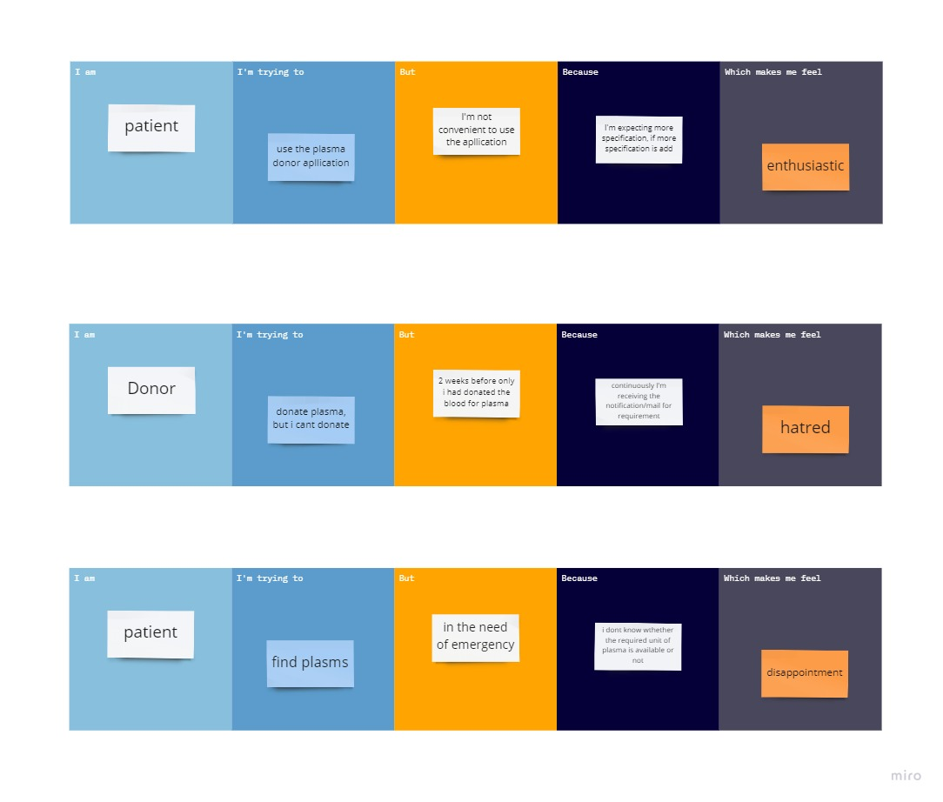

|  |  |  |  |  |  |
| --- | --- | --- | --- | --- | --- |
| **Problem Statement (PS)** | **I am (Customer)** | **I’m trying to** | **But** | **Because** | **Which makes me feel** |
| PS-1 | patient | Use the plasma donor application | I’m not convenient to use the application | I’m expecting more specification, if more specification is add | Enthusiastic |
| PS-2 | donor | Donate plasma, but I cant donate | 2 weeks before only I had donates the blood for plasma | Continuously I’m receiving the notification/mail for requirement | Hatred |